## **Assignment 2: Threaded File Management System**

**Instructor: Dr. Farzana Jabeen (AB)**

**Ali Amir Khawaja 344200**

**Mueed Hassan 347391**

**10-B**

**Tasks**

1. **System design modification**:

In lab 6 users were required to give input commands and guide the system on what to do.

At each step, users manage the system according to their given command. We refactored lab 6 in many ways so it can meet the requirement for lab 11. We read the file, pick one word at a time, store the word into a variable and convert the word to the options that a program needs for execution.

Before we were entering the user input value now we are entering there the option value we get after reading from the file. For example, if the command **create,file1.txt.** First, the create command would be mapped to the option number (in this case 1), which will execute the relevant function.

The program is currently set for a default value of 3 for the number of threads. The number of threads is scalable if more command-based text files are added to the system.

1. **Libraries used:**

* #include <iostream> //standard library for c++
* #include<string> //library for string handling functionality
* #include <fstream> //library for file handling
* #include <cstring> //library for string handling functionality
* #include <thread> //library for creating threads
* #include<windows.h> //implementing general functions
* #include <time.h> //for finding the execution time of the program

1. **System functionalities**: Explain the execution of the threads in your developed program. How many threads can your system support and what is the expected output? Did you find any anomalies in parallel execution threads?

Threads are created in the int main after the creation of each thread process goes into delay and then the next thread is created. Our system supports three threads. When two threads are executed at the same time they might try to reach the same resources so a conflict may occur.

For example, if two threads occur simultaneously and both try to access the same functionality **Create a file** so an error might occur. To solve this problem, we made a change where a delay was added until the function is in use. In the output, we have shown the memory map of each file, according to the command file executed.

1. **Limitations of your system**:

* Size limit: Most file systems have a maximum size limit for the files that they can store. This limit is usually determined by the underlying hardware and the file system itself.
* Concurrent access: File systems may not support simultaneous access by multiple threads, which can lead to delays and reduced performance.
* File locking: File systems may not support file locking, which is the ability to prevent multiple threads from accessing the same file simultaneously. This can lead to race conditions and data corruption.
* Function Reuse: In multi-threaded execution, some commands might call the functions in the same cycle. This could lead to file concurrent execution. A delay can be added to stop the execution of one command and run for the other command one at a time.

1. **Output/Results**: Screenshots of the executed program. sample.dat, input_thread<x>.txt and output_thread<x>.txt.

* **Sample.dat (in this program Assignment1.dat)**

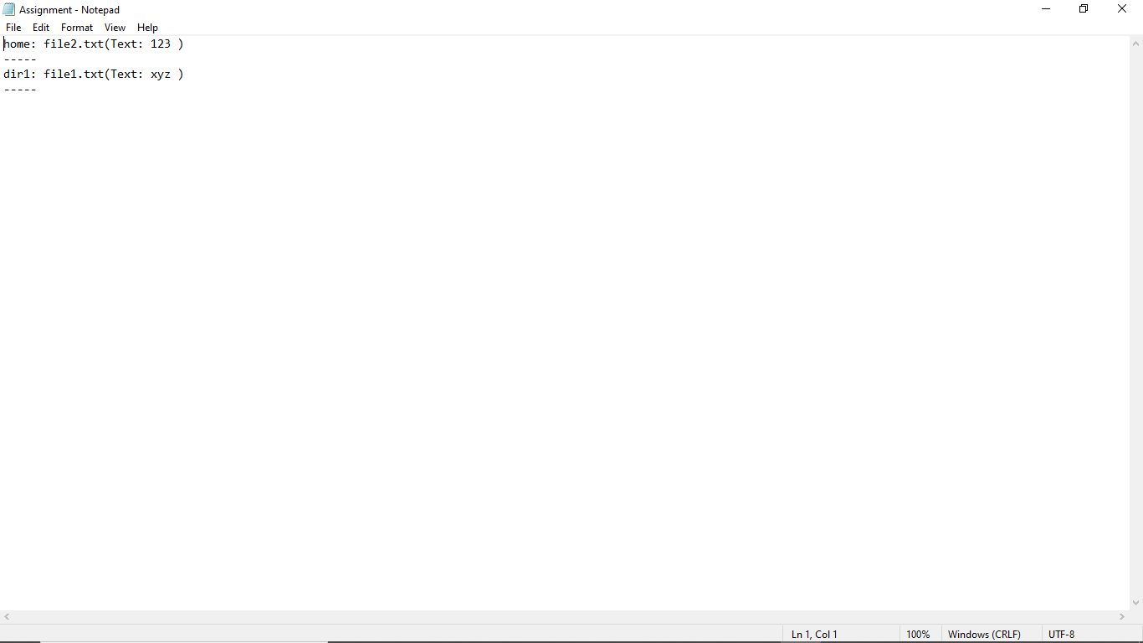

* **Input_thread1.txt (in this program command1.txt)**

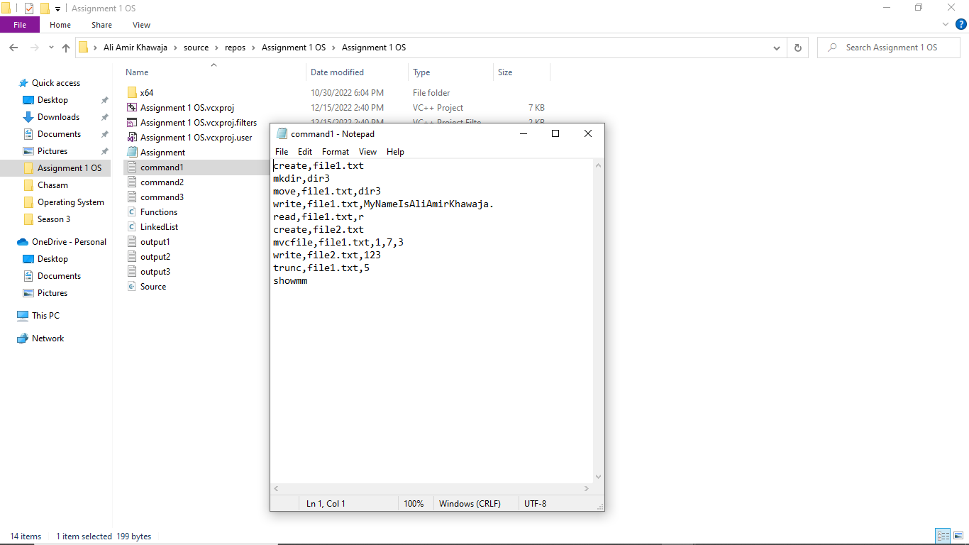

* **Input_thread2.txt (in this program command2.txt)**

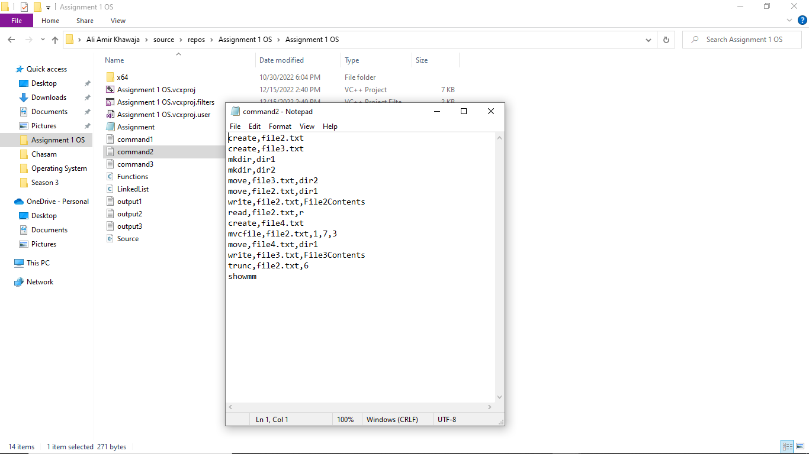

* **Input_thread3.txt (in this program command3.txt)**

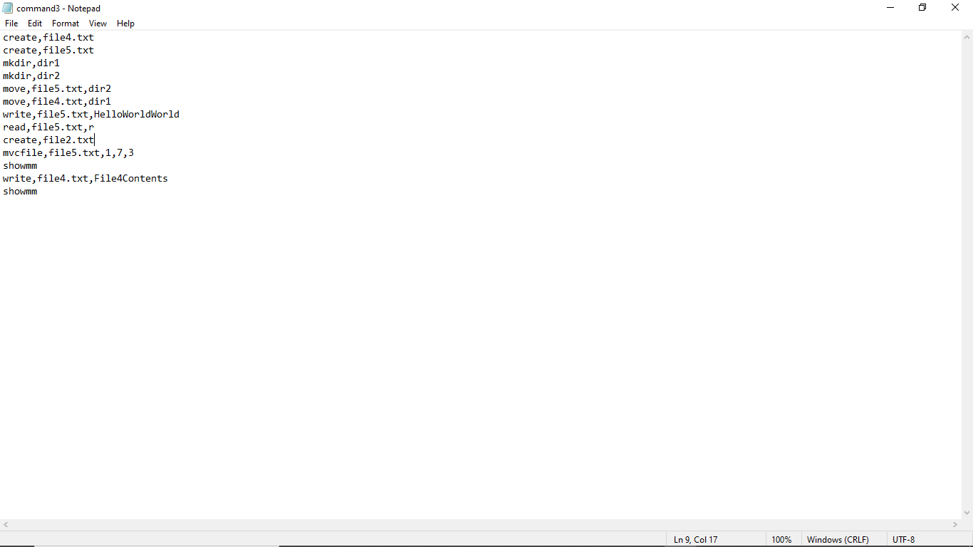

* **output_thread1.txt (in this program output1.txt)**

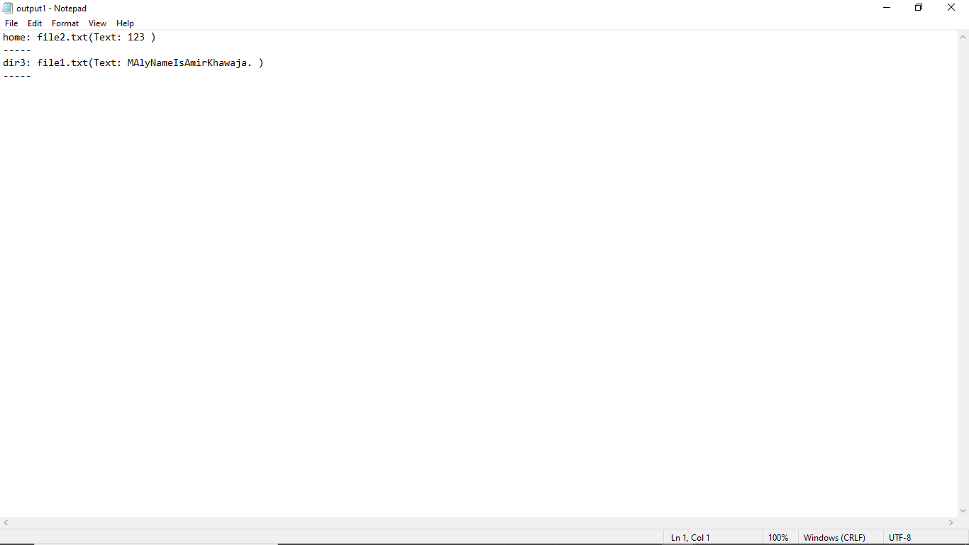

* **output_thread2.txt (in this program output2.txt)**

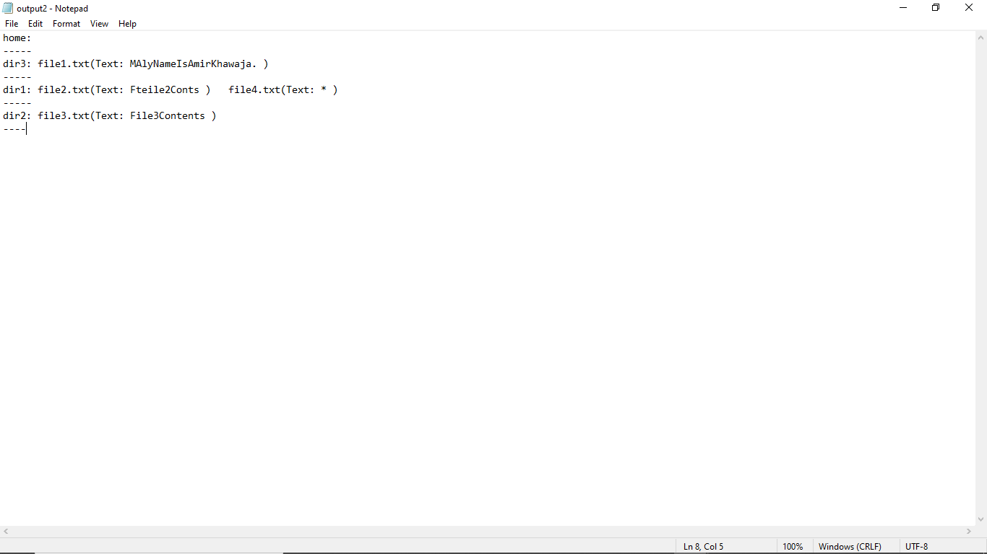

* **output_thread3.txt (in this program output3.txt)**

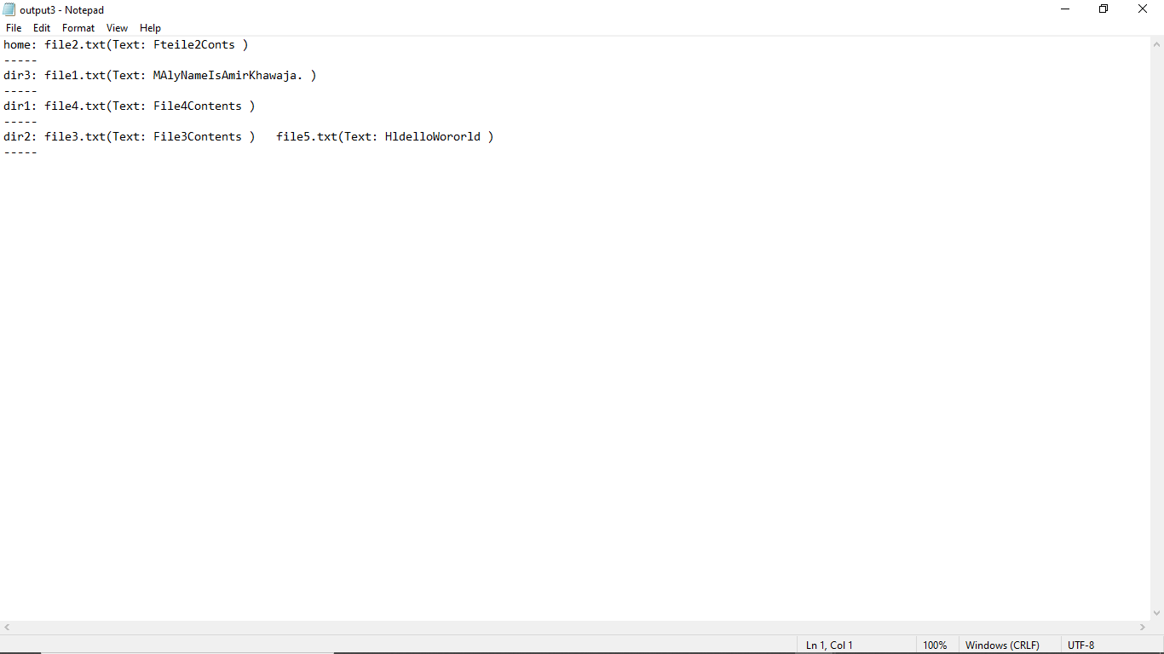

1. **References**: List all the sources you have used as references in implementing your work.

* [**Multithreading in C++**](https://www.geeksforgeeks.org/multithreading-in-cpp/)
* [**C++ Library - <thread>**](https://www.tutorialspoint.com/cpp_standard_library/thread.htm)
* [**How to create an array of thread objects in C++11?**](https://stackoverflow.com/questions/10661792/how-to-create-an-array-of-thread-objects-in-c11)
* [**File Handling through C++ Classes**](https://www.geeksforgeeks.org/file-handling-c-classes/)